**Prediction of Myocardial Infarction Risk in Cardiovascular Disease Using Machine Learning Algorithms**

**INDEX**

**CHAPTER-1**

**INTRODUCTION**

**CHAPTER -2**

**LITERATURE REVIEW**

**CHAPTER – 3**

**METHODOLOGY**

**CHAPTER – 4**

**SOFTWARE DESCRIPTION**

**CHAPTER 5**

**RESULTS AND DISCUSSIONS**

**CHAPTER 6**

**CONCLUSION AND FUTURE WORK**

**REFERENCES**

**ABSTRACT:**

The **"Prediction of Myocardial Infarction Risk in Cardiovascular Disease Using Machine Learning Algorithms"** project aims to develop an intelligent and efficient system for predicting the risk of myocardial infarction (heart attack) by analyzing various patient-specific clinical and lifestyle factors. This predictive system leverages advanced machine learning algorithms to enable early detection, personalized prevention strategies, and improved healthcare outcomes, thus potentially reducing mortality and enhancing quality of life for individuals at risk.

The system is built on a dataset containing vital information, such as patient demographics (age, marital status), medical history (sleep patterns, depression levels, smoking habits, and blood pressure), and key health metrics (cholesterol levels, fasting blood sugar, ECG results, heart rate, exercise-induced angina, and other cardiovascular indicators). By processing this data, the machine learning model can predict the likelihood of a heart attack and identify those who are at a higher risk.

Key components of the system include data preprocessing steps such as handling missing values, detecting and removing duplicates, and encoding categorical data. Exploratory data analysis through visualizations, such as countplots, histograms, and heatmaps, helps in understanding data distributions and relationships among features. The system employs a **Random Forest Classifier** to train the model, which combines the predictions of multiple decision trees to improve accuracy and reduce overfitting. The model is evaluated based on several metrics, including precision, recall, F1-score, and confusion matrix analysis, providing valuable insights into the model's performance.

Once the model is trained and evaluated, it can be saved for future use, allowing for real-time predictions on new data. In the real-world application, the system can be integrated into a user-friendly GUI where healthcare providers or patients input their health parameters. The model then generates risk predictions, indicating whether a myocardial infarction is likely to occur.

**CHAPTER-1**

**INTRODUCTION**

The **"Prediction of Myocardial Infarction Risk in Cardiovascular Disease Using Machine Learning Algorithms"** project marks a significant advancement in personalized healthcare by harnessing the power of machine learning to predict the risk of myocardial infarction (heart attack) in individuals. By analyzing a comprehensive range of patient data, this system provides early detection, allowing healthcare providers to take preventive measures, potentially saving lives and improving overall health outcomes. The innovative approach combines clinical and lifestyle data with machine learning algorithms, empowering both healthcare providers and patients to make informed decisions.

The system is designed to analyze key risk factors for cardiovascular diseases, such as age, marital status, smoking habits, blood pressure, cholesterol levels, diabetes status, and more. This data is processed through a series of well-established machine learning algorithms, with **Random Forest Classifier** being the primary model used for prediction. By examining these factors, the system can accurately assess the likelihood of a myocardial infarction, enabling the identification of high-risk individuals who might benefit from early intervention.

Data preprocessing is a critical aspect of the system, with steps like handling missing values, encoding categorical data, and performing feature scaling to ensure that the input data is clean and ready for analysis. The system also includes extensive exploratory data analysis (EDA), which allows for visualizing relationships between various features and understanding the underlying patterns in the dataset. These insights guide the machine learning model’s ability to predict risk effectively.

The trained model is then evaluated using various performance metrics such as **accuracy**, **precision**, **recall**, **F1-score**, and **AUC-ROC**, ensuring that the model provides reliable and actionable insights. Once validated, the model can be deployed in real-time applications, allowing healthcare professionals to input a patient’s data and receive an instant risk assessment. This real-time feedback is crucial for timely interventions, such as medication adjustments, lifestyle modifications, or closer monitoring of patients at high risk.

**OBJECTIVE:**

The **"Prediction of Myocardial Infarction Risk in Cardiovascular Disease Using Machine Learning Algorithms"** is an innovative solution designed to enhance the early detection of heart attack risks in patients by leveraging the power of machine learning. By analyzing a variety of critical health data, including demographic, clinical, and lifestyle factors, the system provides healthcare professionals with an intelligent tool for predicting the likelihood of myocardial infarction (heart attack) and facilitating timely interventions.

The system employs a comprehensive set of features, such as age, blood pressure, cholesterol levels, diabetes status, smoking habits, and physical activity levels. These factors are processed through a machine learning model, primarily using the **Random Forest Classifier**, which has demonstrated strong predictive capabilities in healthcare applications. The system analyzes these features to generate a personalized risk assessment for each individual, helping healthcare providers identify patients at high risk of experiencing a heart attack.

Data preprocessing plays a vital role in ensuring the accuracy of the model. This involves handling missing values, normalizing data, and encoding categorical variables, all of which are essential steps to make the dataset suitable for analysis. The system also integrates **Exploratory Data Analysis (EDA)** to uncover trends and patterns within the data, ensuring that the machine learning model is well-trained and able to make reliable predictions.

The trained model is evaluated using standard metrics like **accuracy**, **precision**, **recall**, **F1-score**, providing a robust measure of its performance. Once validated, the model is deployed in real-time applications, allowing healthcare providers to input a patient’s data and instantly receive a risk prediction for myocardial infarction. This prompt feedback allows for immediate action, such as prescribing medication, recommending lifestyle changes, or scheduling additional tests.

The system is designed with user-friendliness in mind, offering an intuitive interface that allows healthcare providers to enter patient data and receive results in seconds. Alerts and risk classifications are generated, helping clinicians make informed decisions about patient care and ensuring that high-risk individuals receive timely treatment.

Looking to the future, the system can be further enhanced by integrating real-time health data from wearable devices, such as heart rate monitors and ECG devices, which could improve the prediction accuracy and offer continuous monitoring of cardiovascular health. Additionally, a mobile app or cloud-based platform could be developed to provide patients with direct access to their risk assessments and recommendations for prevention.

**SCOPE OF THE PROJECT**

This project focuses on leveraging machine learning algorithms to predict the risk of myocardial infarction (heart attack) in individuals with cardiovascular disease. By analyzing key health indicators, the system provides healthcare professionals with an advanced tool for early detection and intervention, ultimately reducing the incidence of heart attacks and improving patient outcomes.

The scope of the project includes the following key components:

1. **Data Collection and Preprocessing**: The system collects various health-related features, including age, blood pressure, cholesterol levels, smoking habits, diabetes status, and physical activity. These features are preprocessed to handle missing values, normalize data, and encode categorical variables, ensuring the dataset is clean and ready for analysis.
2. **Machine Learning Model**: The system utilizes a **Random Forest Classifier**, a robust machine learning algorithm known for its ability to handle complex healthcare data and make accurate predictions. The model is trained on a large dataset containing patient information and known outcomes, enabling it to learn the patterns and relationships between the input features and the risk of myocardial infarction.
3. **Model Evaluation**: After training the model, its performance is evaluated using standard metrics such as **accuracy**, **precision**, **recall**, **F1-score**. These metrics help ensure that the model is effective in predicting heart attack risks, allowing healthcare providers to trust its predictions and take timely action.
4. **Real-Time Risk Prediction**: Once validated, the model is deployed to allow healthcare providers to input real-time patient data and receive immediate risk predictions for myocardial infarction. The system’s ability to offer instant feedback enables healthcare professionals to make quick decisions, such as recommending preventive treatments or scheduling further diagnostic tests.
5. **User Interface and Alerts**: A user-friendly interface is designed for healthcare professionals, allowing them to easily input patient data and view the risk assessment results. The system provides clear information, helping clinicians identify risk of patients and initiate preventive measures early on.
6. **Industry Impact**: By integrating machine learning into the healthcare process, this system has the potential to significantly reduce the number of heart attack-related fatalities. Its ability to provide personalized risk predictions can guide patient care more effectively, leading to better health outcomes. Additionally, the system’s scalability allows it to be used in various healthcare settings, from hospitals to primary care clinics, enhancing cardiovascular disease management at all levels.

**SIGNIFICANCE**

Timely prediction of myocardial infarction (heart attack) risk is essential for preventing cardiovascular events and improving patient outcomes. Traditional methods for assessing heart attack risk often rely on manual evaluations and basic diagnostic tools, which can be insufficient in identifying high-risk patients early. The **Prediction of Myocardial Infarction Risk in Cardiovascular Disease Using Machine Learning Algorithms** provides a more efficient and accurate solution by leveraging advanced machine learning techniques to assess heart attack risk based on various health factors, reducing the likelihood of adverse events.

By utilizing a **Random Forest Classifier**, the system analyzes key health indicators such as age, blood pressure, cholesterol levels, smoking habits, diabetes status, and physical activity. This data-driven approach allows for early detection of individuals at high risk for myocardial infarction. The machine learning model processes the input features and outputs a risk prediction, enabling healthcare professionals to take timely and targeted actions.

The system operates in real-time, providing healthcare providers with immediate risk predictions based on patient data. This allows for early intervention, such as recommending preventive treatments or scheduling further diagnostic tests, to mitigate the risk of a heart attack. The integration of machine learning algorithms ensures the accuracy and reliability of the predictions, offering a significant improvement over traditional methods.

With the use of cost-effective technologies and open-source tools, the system is designed to be accessible and scalable for widespread implementation. It can be seamlessly integrated into healthcare facilities, ranging from primary care clinics to large hospitals, making it a valuable tool for improving cardiovascular disease management. The system’s ability to predict heart attack risk with high accuracy not only helps in saving lives but also contributes to reducing healthcare costs by preventing heart attack-related complications and hospitalizations.

By automating the risk prediction process, this system enhances early detection and intervention, leading to better patient care and outcomes. Its adaptability ensures that it can be used across diverse healthcare environments, helping to prevent myocardial infarctions and improve the overall management of cardiovascular disease.

**CHAPTER -2**

**LITERATURE REVIEW**

**Prediction of Myocardial Infarction Risk in Cardiovascular Disease Using Machine Learning Algorithms (Gurpreet Singh, Kalpna Guleria, Shagun Sharma, Chitkara University, Punjab, India)**This study focuses on the application of machine learning (ML) and deep learning (DL) algorithms to predict the risk of myocardial infarction (heart attack) in individuals with cardiovascular disease (CVD). The researchers aim to identify the most effective predictive models for early detection of heart disease. The models used in this study include **Naive Bayes**, **Multilayer Perceptron (MLP)**, **Decision Tree**, and **Logistic Regression**.The study highlights the importance of precise and early prediction in reducing the fatality rate associated with heart disease and underscores the value of machine learning algorithms in improving diagnostic accuracy for cardiovascular conditions.

**M. Limbitote**, "A survey on prediction techniques of heart disease using machine learning," Int. J. Eng. Res. Technol. (Ahmedabad), vol. V9, no. 06, 2020. This study provides a comprehensive survey on the various machine learning techniques used for predicting heart disease. It explores different approaches, including classification algorithms and feature selection methods, to improve the accuracy and efficiency of heart disease prediction. The survey highlights the potential of machine learning in aiding early diagnosis and the development of intelligent systems for healthcare applications. It emphasizes the growing importance of these techniques in advancing predictive healthcare models for heart disease.

**A. H. Gonsalves**, **F. Thabtah**, **R. Mustafa**, **A. Mohammad**, and **G. Singh**, "Prediction of coronary heart disease using machine learning: an experimental analysis," Proceedings of the 2019 3rd International Conference on Deep Learning Technologies, pp. 51-56, 2019. This study presents an experimental analysis of machine learning models applied to the prediction of coronary heart disease. It evaluates various machine learning algorithms for their effectiveness in diagnosing heart disease based on patient data, focusing on optimizing prediction accuracy. The research emphasizes the potential of machine learning in providing early and accurate detection of coronary heart disease, which can aid in timely intervention and improve patient outcomes.

**CHAPTER – 3**

**METHODOLOGY**

Myocardial infarction (heart attack) is one of the leading causes of death globally, making the early detection of individuals at high risk a critical aspect of cardiovascular healthcare. The **Prediction of Myocardial Infarction Risk in Cardiovascular Disease Using Machine Learning Algorithms** is a data-driven approach that uses a variety of health indicators to assess the likelihood of a heart attack. It helps healthcare providers identify patients who are at high risk, enabling timely intervention to prevent adverse cardiovascular events. The key elements of this process include:

* **Risk Identification**: Predicting the risk of a heart attack based on a set of health features such as age, blood pressure, cholesterol levels, smoking habits, diabetes status, and more.
* **Improved Healthcare Decision-Making**: Providing real-time risk scores that aid doctors in making informed decisions about treatment options, preventive measures, and lifestyle changes.
* **Targeted Intervention**: Identifying high-risk individuals enables healthcare providers to initiate timely preventive interventions such as lifestyle changes, medication, or more frequent monitoring to reduce the likelihood of a heart attack.
* **Early Detection**: Machine learning models can detect patterns that may not be immediately obvious through traditional assessment methods, identifying individuals who are at risk even before symptoms appear.

**Challenges in Traditional Myocardial Infarction Risk Prediction:**

Traditional methods of predicting myocardial infarction risk rely on manual assessments and basic diagnostic tests, which have several limitations:

* **Slow and Reactive**: Current risk assessment tools often rely on periodic checkups, which may delay the identification of high-risk individuals, leaving little time for proactive interventions.
* **Subjectivity**: Risk assessment can vary depending on the healthcare provider’s experience and judgment, leading to potential inconsistencies and missed opportunities for early intervention.
* **Over-Reliance on Basic Metrics**: Conventional methods often focus on general indicators such as cholesterol levels or blood pressure, missing out on more complex patterns that could predict myocardial infarction.

**Advanced Machine Learning Approach for Myocardial Infarction Risk Prediction:**

* **Data-Driven Analysis**: Machine learning models, such as random forests or neural networks, analyze large volumes of medical data to accurately assess risk factors and predict the likelihood of a heart attack.
* **Comprehensive Feature Utilization**: The system leverages a wide range of health parameters, from age and blood pressure to more nuanced factors like stress levels, family history, and lifestyle habits, offering a more complete assessment of heart attack risk.
* **Enhanced Predictive Accuracy**: By analyzing complex patterns in data, machine learning algorithms can detect early signs of risk that traditional methods might overlook.
* **Real-Time Risk Assessment**: The model offers instant predictions based on current health data, allowing healthcare professionals to intervene immediately, reducing the chances of heart attack occurrences.
* **Scalable and Automated**: This system can be deployed across healthcare facilities to assess risk for large patient populations, making it a scalable and automated solution for proactive heart disease management.

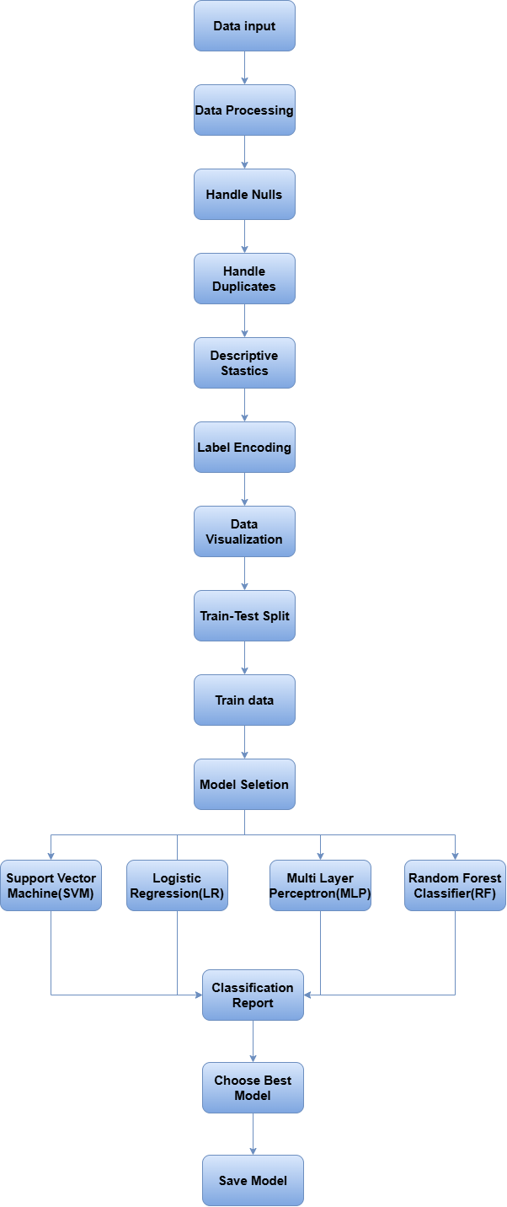

### 1. Data Input

The dataset contains various features such as Age, Marital Status, Sleep Patterns, Depression Levels, Smoking Habits, and medical parameters like Blood Pressure, Cholesterol Levels, and Heart Rate, aimed at predicting the likelihood of myocardial infarction. The target variable, Mortality Status, indicates whether the patient survived or succumbed to the condition.

**1. marital_status**

* Indicates the marital status of an individual (e.g., single, married, divorced, or widowed).
* **Relevance**: Marital status can influence stress levels and lifestyle choices, which are risk factors for heart disease.

**2. sleep**

* Refers to the duration and quality of sleep.
* **Relevance**: Poor sleep patterns are associated with increased cardiovascular risk due to stress, hormonal imbalances, and poor recovery.

**3. depression**

* Measures levels of depression, often through scales or questionnaires.
* **Relevance**: Depression is linked to unhealthy lifestyle habits and physiological stress responses, increasing the risk of heart disease.

**4. smoking**

* Indicates smoking habits (e.g., smoker, non-smoker, former smoker).
* **Relevance**: Smoking damages blood vessels, raises blood pressure, and contributes to atherosclerosis, a leading cause of myocardial infarction.

**5. chol (Cholesterol Levels)**

* Measures the total cholesterol in the blood.
* **Relevance**: High cholesterol contributes to plaque buildup in arteries, increasing the risk of a heart attack.

**6. fbs (Fasting Blood Sugar)**

* Represents fasting blood sugar levels, typically measured in mg/dL.
* **Relevance**: High fasting blood sugar is a sign of diabetes, a significant risk factor for cardiovascular diseases.

**7. restecg (Resting Electrocardiographic Results)**

* Indicates ECG results at rest, categorized as normal or showing abnormalities such as left ventricular hypertrophy or ST-T wave abnormalities.
* **Relevance**: Abnormal ECG results can signal heart conditions or stress on the heart.

**8. thalach (Maximum Heart Rate Achieved)**

* The highest heart rate reached during physical exertion or a stress test.
* **Relevance**: A lower-than-expected maximum heart rate may indicate heart problems.

**9. exang (Exercise-Induced Angina)**

* Indicates whether angina (chest pain) occurs during exercise.
* **Relevance**: Exercise-induced angina is a strong indicator of underlying coronary artery disease.

**10. diabetes**

* Reflects whether the individual has diabetes.
* **Relevance**: Diabetes increases the risk of cardiovascular issues by promoting atherosclerosis and damaging blood vessels.

**11. bp (Blood Pressure)**

* Represents blood pressure readings, typically systolic (top number) and diastolic (bottom number).
* **Relevance**: High blood pressure increases the workload on the heart and can lead to arterial damage.

**12. hypersensitivity**

* Refers to the presence of allergic reactions or overactive immune responses.
* **Relevance**: Chronic inflammation or hypersensitivity may contribute to heart disease development.

**13. cp (Chest Pain Type)**

* Categorizes the type of chest pain experienced, such as typical angina, atypical angina, non-anginal pain, or no chest pain.
* **Relevance**: Chest pain type helps in diagnosing myocardial infarction.

**14. trestbps (Resting Blood Pressure)**

* Indicates blood pressure when the individual is at rest.
* **Relevance**: High resting blood pressure is a common risk factor for heart disease.

**15. oldpeak**

* Measures ST depression relative to rest during exercise, a metric in stress tests.
* **Relevance**: High ST depression suggests ischemia, indicating restricted blood flow to the heart.

**16. slope**

* Represents the slope of the ST segment during peak exercise, categorized as upsloping, flat, or downsloping.
* **Relevance**: Abnormal slopes often indicate myocardial ischemia or other heart issues.

**17. ca (Number of Major Vessels)**

* The number of major coronary arteries (0–3) visible under fluoroscopy.
* **Relevance**: Higher numbers indicate fewer blockages, while lower numbers suggest significant blockages.

**18. thal (Thalassemia)**

* Refers to a blood disorder or the presence of fixed defects, reversible defects, or normal perfusion in a stress test.
* **Relevance**: Abnormalities can indicate blood supply issues or anemia, both relevant to heart health.

### 2. Data Processing

#### **2.1 Handle Nulls**

Identify and handle missing values by either imputing with the mean/median (for numerical data) or mode (for categorical data), or removing rows/columns with excessive nulls.

#### **2.2 Handle Duplicates**

Detect and remove duplicate rows to ensure the dataset is clean and avoid bias in model training.

#### **2.3 Descriptive Statistics**

Generate summary statistics (mean, median, standard deviation, min, max) to understand the distribution of numerical features and detect any outliers or skewed data.

### 3. Label Encoding

Label Encoding is used to convert categorical variables into numerical values. The LabelEncoder from sklearn.preprocessing is applied to the specified columns (Marital_status, Sleep, Depression, Smoking, Hypersensitivity). Each categorical value in these columns is transformed into a unique integer, making the data suitable for machine learning models. The .astype(int) ensures the encoded values are in integer format.

### 4. Data Visualization

#### 4.1 Countplot for Mortality

Shows the distribution of patients who survived vs. those who did not, based on the "Mortality" variable.

#### **4.2 Histogram for Age**

Visualizes the distribution of ages in the dataset, indicating how frequently different age groups occur.

#### **4.3 Histogram for Cholesterol (Chol)**

Displays the distribution of cholesterol levels, showing how common different cholesterol values are in the dataset.

#### **4.4 Pie Chart for Smoking**

Illustrates the proportion of smokers vs. non-smokers in the dataset, providing insight into smoking habits.

#### **4.5 Countplot for Mortality by Age**

Visualizes the count of survivors vs. non-survivors, broken down by different age groups, highlighting age-related trends in mortality.

#### **4.6 Pairplot**

Shows pairwise relationships and distributions of all numerical features, helping to identify patterns and correlations between variables.

#### **4.7 Heatmap of Correlations**

Displays a heatmap to show correlations between numerical features, helping to identify highly correlated variables.

### 5. Train-Test Split

Splits the dataset into training (70%) and testing (30%) sets, ensuring proportional distribution of the target variable using stratify=Y. The value_counts() on y_train shows the distribution of the target in the training set. Prints the number of samples in the training and test sets, along with the total dataset size.

### 6. Model Selection

* **SVM**: Best for binary classification problems, especially when the decision boundary is not easily separable.
* **Logistic Regression**: A simple, interpretable model for binary classification, especially if the relationship between input features and the target is linear.
* **MLP**: A neural network that can model complex relationships in data but requires more data and computational resources.
* **Random Forest**: A robust ensemble model that combines multiple decision trees to improve accuracy and reduce overfitting. It’s especially effective when dealing with complex, noisy data.

### 7. Model Evaluation

#### **7.1 Classification Report**

The classification report provides performance metrics for the model, including precision, recall, F1-score, and support for each class.

#### **7.2 Accuracy**

* The overall accuracy of the model is 99%, indicating that 99% of the predictions were correct.

#### **7.3 Precision**

* For class 0, precision is 0.99, meaning 99% of the predicted positives were actually correct.
* For class 1, precision is 1.00, meaning all predicted positives were correct.

#### **7.4 Recall**

* For class 0, recall is 1.00, meaning all actual positives of class 0 were correctly identified.
* For class 1, recall is 0.96, meaning 96% of the actual positives of class 1 were correctly identified.

#### **7.5 F1-Score**

* The F1-score for class 0 is 0.99 and for class 1 is 0.98, balancing precision and recall for each class.

#### **7.6 Support**

* Support refers to the number of true instances for each class in the test set (87 for class 0 and 24 for class 1).

### 7.7 Confusion Matrix

The confusion matrix visualizes true positives, false positives, true negatives, and false negatives, providing insights into how well the model is distinguishing between classes.

### 7.8 Choose Best Model

* **Comparison**: Based on the classification report, the model that gives the best performance is chosen.
* **Consideration**: If false negatives (missed heart attack cases) are critical, a model prioritizing recall may be selected.

### 8. Save Model

* **Serialization**: Once the best model is chosen, it is saved using joblib or pickle, so it can be loaded and used for future predictions without retraining.
* **Deployment**: The saved model is integrated into a system where new patient data can be input, and the model will output whether the patient is at risk of a heart attack.

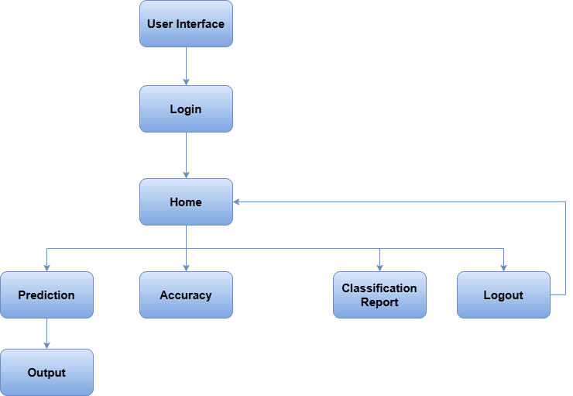**USER INTERFACE:**

1. **User Interface and Login**

The process begins with a user interface where the user enters their credentials to log in. This ensures data security and privacy.

1. **Home Page**

After successful login, the user lands on the home page. This page serves as the central hub for accessing different functionalities.

* 1. **Prediction**

This is the core step where the ML model predicts the MI risk. Here's a breakdown of the process:

The user's relevant medical data (age, blood pressure, cholesterol levels, smoking habits, etc.) is collected.The chosen ML algorithm is **Random Forest**, an ensemble method that combines multiple decision trees to improve accuracy and robustness.The Random Forest model is trained on historical data of patients with known MI outcomes. The model learns to identify patterns and relationships between the input features and the target variable.The trained model is then used to predict the MI risk for the new user based on their input data.The predicted MI risk is presented to the user in a clear and understandable format. This could be:

**Output:**

**Heart stroke will occur**

**Heart stroke will not occur**

1. **Accuracy :**

These sections provide insights into the performance of the ML model:

* **Accuracy**: Measures the overall correctness of the predictions accuracy percentages of each model.

**4**. **Classification Report:**

* **Classification Report**: Shows various metrics like precision, recall, F1-score, and support for different risk categories. This helps assess the model's ability to correctly identify patients at different risk levels.

1. **Logout:**

The user can log out of the system to ensure data security and privacy and moves to home page.

**CHAPTER – 4**

**SOFTWARE DESCRIPTION**

**Visual Studio Code (VS Code)**

Visual Studio Code is a lightweight yet powerful source code editor developed by Microsoft. It supports multiple programming languages and provides robust features like syntax highlighting, debugging, and version control. With its extensibility through extensions, it becomes an ideal choice for Python development, including machine learning projects.

* **Key Features for this Project:**
  + **Python Support:** Enhanced with the Python extension for debugging, linting, and IntelliSense.
  + **Integrated Terminal:** Simplifies the execution of commands for tasks like virtual environment creation.
  + **Workspace Customization:** Allows the organization of files and folders for streamlined project management.
  + **Version Control Integration:** Built-in support for Git ensures easy collaboration and version tracking.

**Python 3.10 and Python Extension**

Python 3.10 is a widely used version of Python, offering new features such as structural pattern matching and improved error messages. The Python extension in VS Code enables a seamless development experience with features like:

* IntelliSense for code completion.
* Code linting using tools like pylint or flake8.
* Integrated Jupyter Notebook support for interactive data analysis and model training.

**Adding a Folder to Workspace**

To organize project files efficiently:

1. In VS Code, click on **File > Add Folder to Workspace**.
2. Select the folder containing your project files (e.g., dataset, scripts, notebooks).
3. The folder will appear in the Explorer pane, allowing easy access to project files and directories.

**Using requirements.txt**

The requirements.txt file lists all the Python dependencies required for the project. It ensures reproducibility and simplifies dependency installation for collaborators or when deploying the project.

1. **Creating the File:**
   * After installing the necessary packages (e.g., pandas, numpy, scikit-learn, tensorflow), generate the file using:



1. **Installing Dependencies:**
   * To install all required packages in a new environment, run:



**Setting Up the Development Environment**

**Creating a Virtual Environment**

A virtual environment isolates project dependencies, ensuring compatibility and preventing conflicts with global installations. To create a virtual environment for the gestational diabetes prediction project:

1. Open the integrated terminal in VS Code.
2. Navigate to the project directory using cd <project-directory>.
3. Run the following command to create a virtual environment:



Here, venv is the name of the virtual environment folder.

1. Activate the virtual environment:
   * **Windows:**



1. Once activated, the terminal prompt will indicate the virtual environment name.

**1. pandas**

**Explanation:**  
pandas is a powerful data manipulation and analysis library that provides data structures like **DataFrames** and **Series**. It is widely used for handling structured data.

**Actions:**

* Reading and writing data (CSV, Excel, JSON, SQL, etc.).
* Data cleaning (handling missing values, duplicates).
* Data transformation (filtering, sorting, grouping).
* Statistical analysis.

**Use Cases:**

* Cleaning and preprocessing medical records for MI prediction.
* Handling large datasets efficiently in finance and business analytics.
* Manipulating time-series data in stock market analysis.

**2.numpy**

**Explanation:**  
numpy (Numerical Python) provides efficient numerical computations and supports large, multi-dimensional arrays and matrices.

**Actions:**

* Fast mathematical operations (addition, multiplication, etc.).
* Generating random numbers.
* Linear algebra and Fourier transforms.
* Handling large datasets efficiently.

**Use Cases:**

* Performing matrix operations in deep learning models.
* Handling sensor data in IoT applications.
* Computing medical image processing tasks.

**3. scikit-learn**

**Explanation:**  
scikit-learn is a machine learning library that provides simple and efficient tools for data mining, analysis, and modeling.

**Actions:**

* Building and training machine learning models (classification, regression, clustering).
* Feature selection and engineering.
* Model evaluation and hyperparameter tuning.

**Use Cases:**

* Predicting myocardial infarction (MI) risk using Random Forest.
* Fraud detection in banking and finance.
* Customer segmentation using clustering algorithms.

**4. matplotlib**

**Explanation:**  
matplotlib is a visualization library used for creating static, animated, and interactive plots.

**Actions:**

* Plotting line graphs, bar charts, histograms, and scatter plots.
* Customizing graphs with labels, legends, and colors.
* Creating subplots and multi-figure layouts.

**Use Cases:**

* Visualizing patient risk distribution in MI prediction.
* Representing financial trends in stock market analysis.
* Displaying real-time sensor data in IoT applications.

**5. seaborn**

**Explanation:**  
seaborn is a statistical data visualization library built on top of matplotlib, designed for more attractive and informative plots.

**Actions:**

* Creating advanced visualizations (heatmaps, violin plots, pair plots).
* Enhancing data insights with easy-to-use functions.
* Automatic handling of statistical aggregations.

**Use Cases:**

* Visualizing correlation between MI risk factors (age, cholesterol, smoking).
* Analyzing customer behavior trends in marketing.
* Detecting outliers in fraud detection models.

**6. imbalanced-learn**

**Explanation:**  
imbalanced-learn is a machine learning library that deals with imbalanced datasets, where one class significantly outnumbers another.

**Actions:**

* Oversampling (SMOTE) to generate synthetic samples.
* Undersampling to balance the dataset.
* Handling class imbalance in machine learning models.

**Use Cases:**

* Balancing datasets in MI risk classification where healthy patients outnumber MI cases.
* Fraud detection in financial transactions.
* Anomaly detection in network security.

**7. Flask**

**Explanation:**  
Flask is a lightweight web framework used to build APIs and web applications in Python.

**Actions:**

* Creating RESTful APIs for ML model deployment.
* Handling HTTP requests (GET, POST).
* Integrating machine learning models into web applications.

**Use Cases:**

* Deploying MI risk prediction as a web application.
* Building chatbot interfaces for healthcare support.
* Creating dashboards for real-time analytics.

**8. joblib**

**Explanation:**  
joblib is a library used for saving and loading Python objects, such as machine learning models and large datasets, efficiently.

**Actions:**

* Saving trained models for later use.
* Loading models quickly without retraining.
* Parallelizing computations for faster execution.

**Use Cases:**

* Storing and reusing trained MI prediction models.
* Caching large datasets for performance optimization.
* Speeding up machine learning workflows.

**CHAPTER 5**

**RESULTS AND DISCUSSIONS**

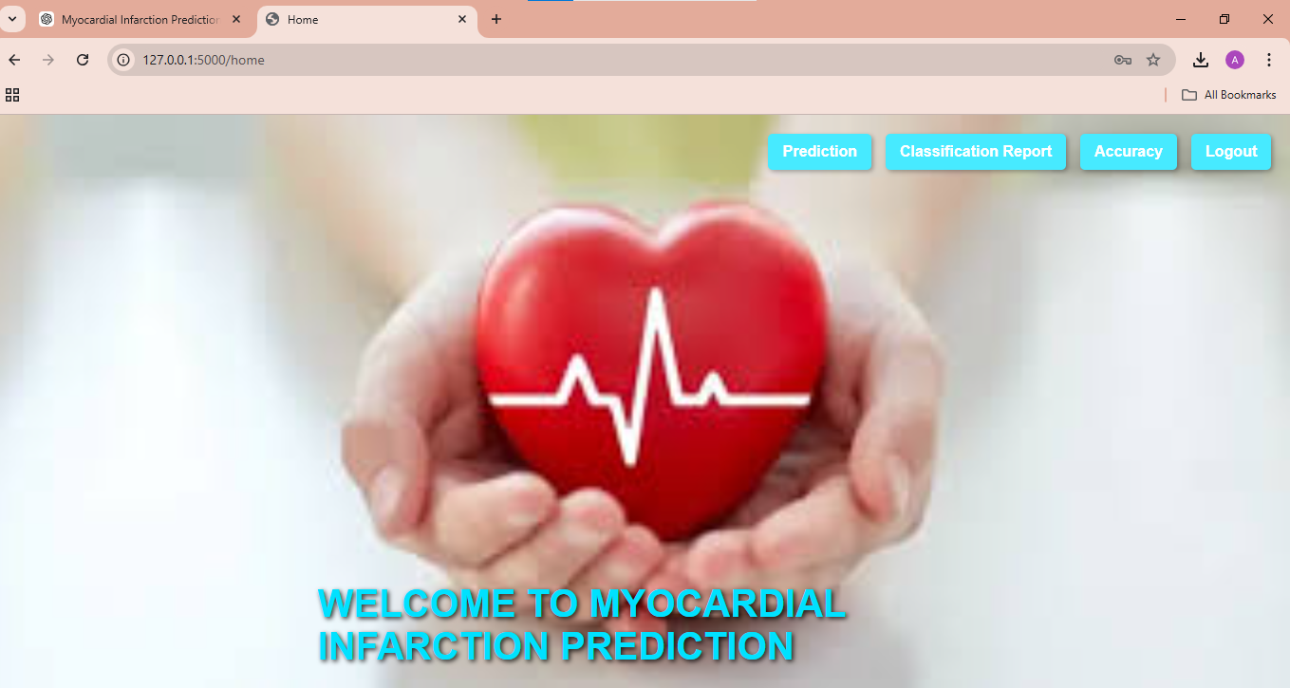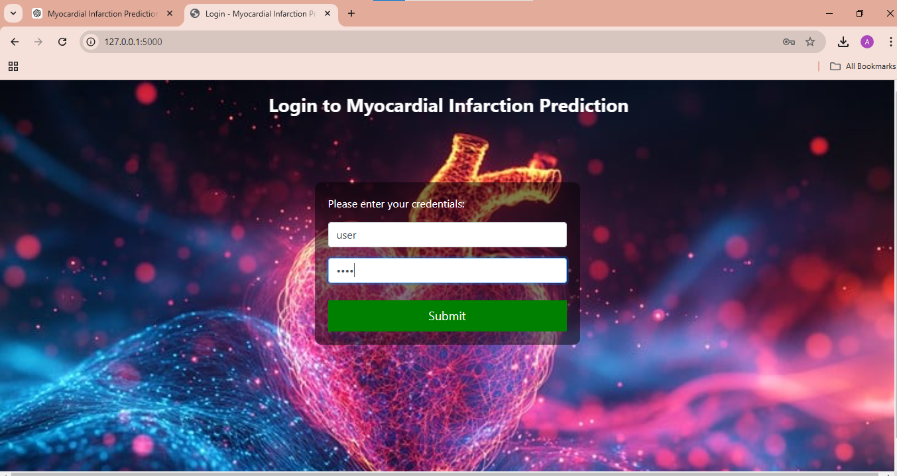

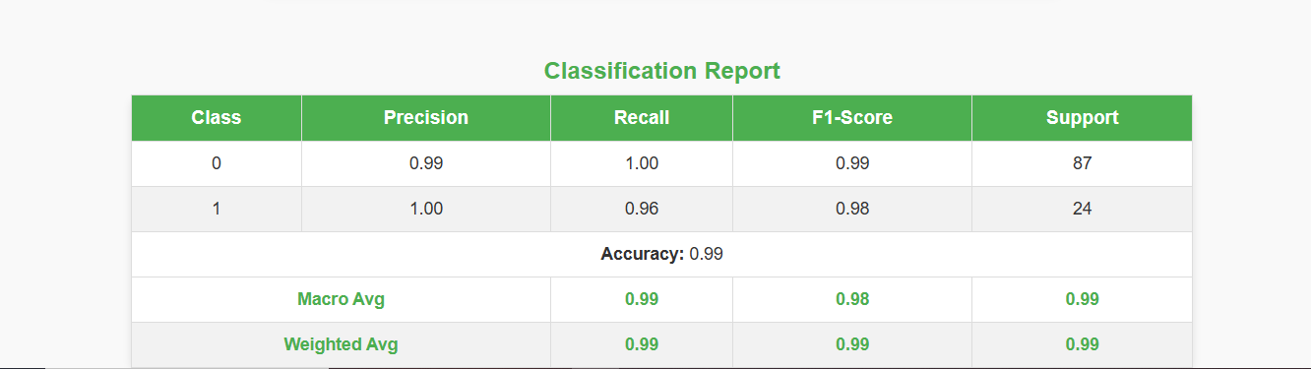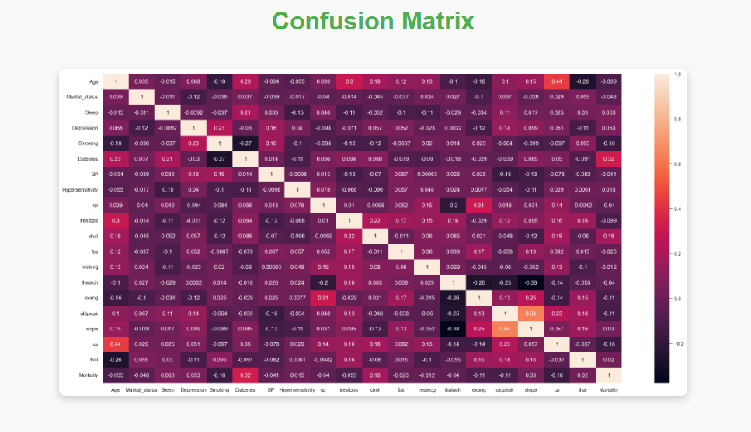

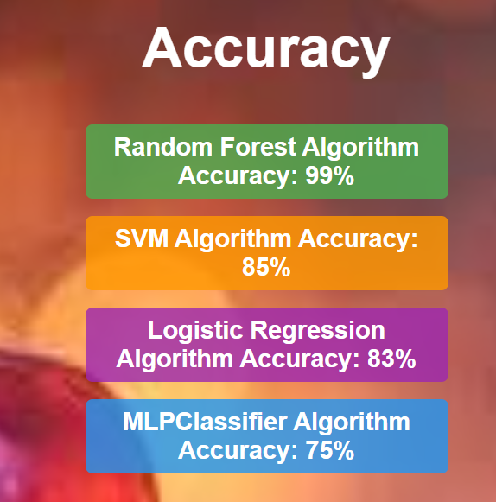

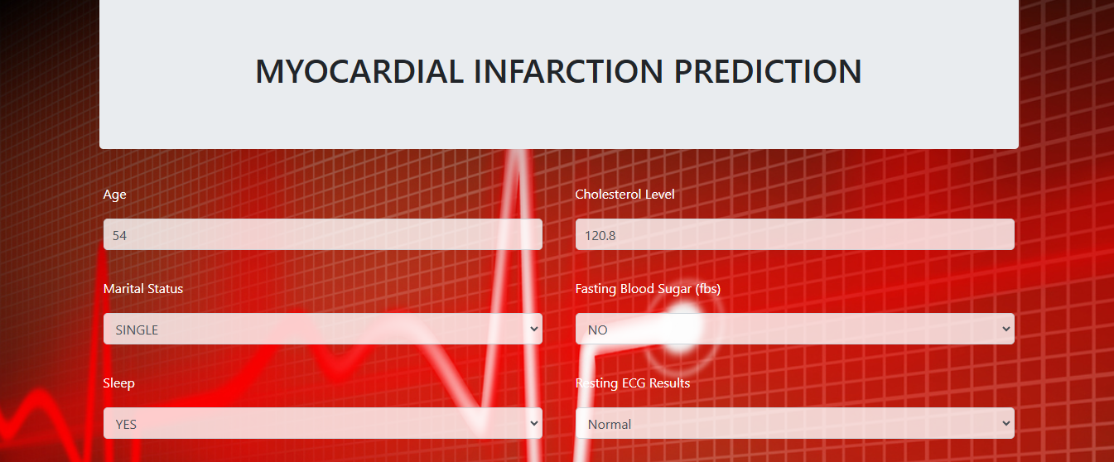

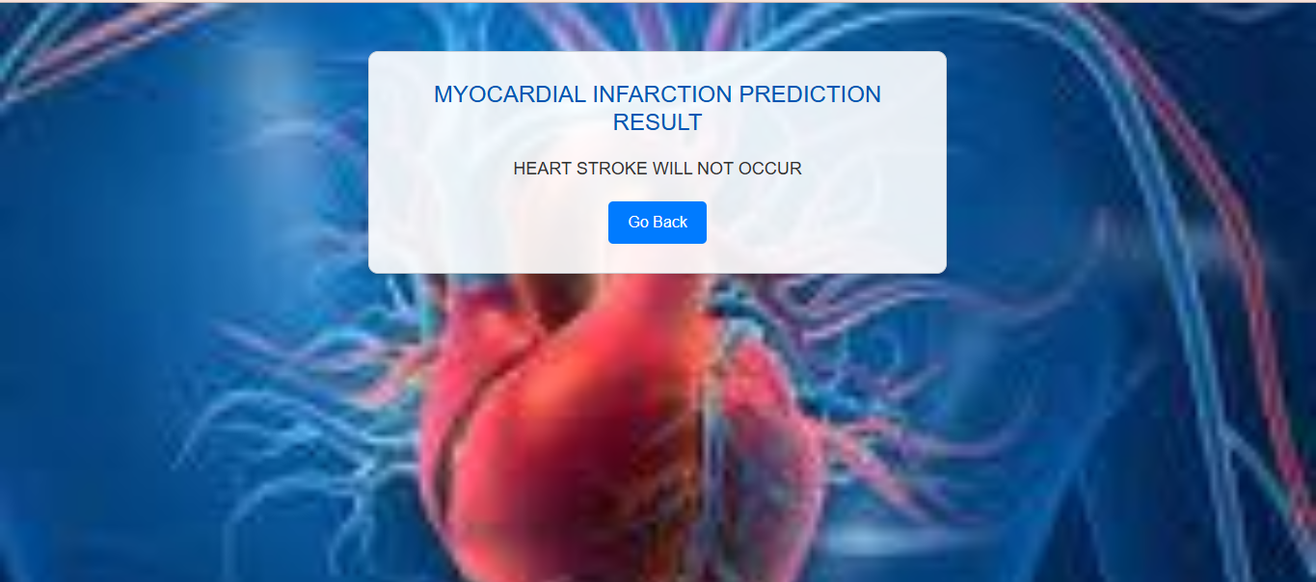

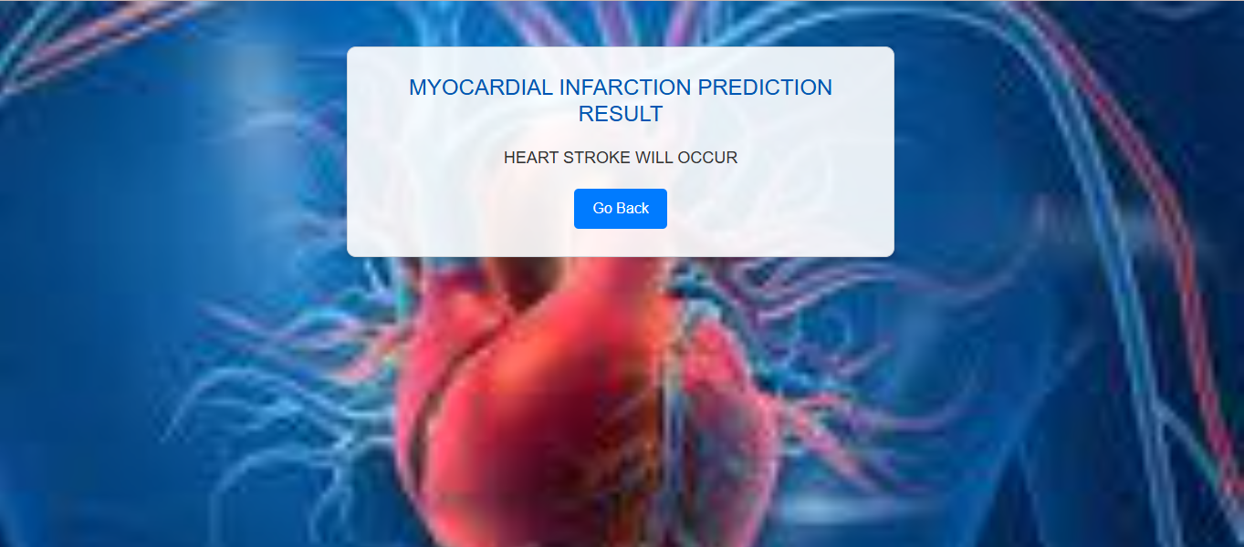

**CHAPTER 6**

**CONCLUSION AND FUTURE WORK**

**Conclusion**

The **Prediction of Myocardial Infarction (MI) Risk** system is an advanced AI-powered solution designed to assess an individual's risk of heart attack based on key medical indicators. By leveraging **machine learning algorithms**, this system provides early detection of high-risk patients, enabling proactive healthcare interventions and reducing mortality rates associated with cardiovascular diseases.

Traditional risk assessment methods rely on manual analysis and general risk factors, often leading to late diagnoses. This system utilizes **Random Forest**, a powerful machine learning algorithm, to analyze critical health parameters such as **age, blood pressure, cholesterol levels, smoking habits, diabetes status, and heart rate variability**. The model learns from historical patient data to predict MI risk with high accuracy, offering personalized insights for better clinical decision-making.

The system processes patient data through a secure **web-based interface**, where users can input relevant health metrics. The trained **Random Forest model** then evaluates the data and provides a detailed risk prediction. A classification report further enhances interpretability by displaying key performance metrics like **accuracy, precision, recall, and F1-score**.

**Future Work**

1. **Integration with Wearable Devices & Mobile Apps**
   * **Real-time Data Collection**: Integrate with wearable devices (smartwatches, fitness trackers) to monitor health parameters like heart rate and blood pressure for real-time risk prediction.
   * **App Development**: Create a mobile app for users to view health status, risk predictions, trends, and receive recommendations.
2. **Improved Prediction Models**
   * **Advanced Machine Learning**: Use complex models (LSTM, CNN) for better prediction accuracy by capturing temporal patterns in health data.
   * **Real-Time Retraining**: Implement continuous model updates with new data to enhance prediction performance over time.
3. **Automated Alerts & Notifications**
   * **Threshold Alerts**: Set dynamic health parameter thresholds to trigger alerts for users and healthcare providers.
   * **Emergency Integration**: Automatically notify emergency services with health data and geolocation in case of high-risk predictions.
   * **Customizable Alerts**: Allow users/providers to set personalized alert thresholds.
4. **Patient & Healthcare Provider Dashboard**
   * **Provider Dashboard**: Build a real-time monitoring dashboard for healthcare providers to track multiple patients and assist in decision-making.
   * **Patient History**: Enable patients to maintain a record of health data, predictions, and interventions for doctors' reference.
5. **Integration with EHR (Electronic Health Records)**
   * **Seamless Data Sharing**: Integrate with EHR systems for easy access to updated patient data.
   * **Data Interoperability**: Ensure smooth data exchange across different healthcare platforms for better diagnosis.
6. **Personalized Preventive Strategies**
   * **Lifestyle Recommendations**: Offer personalized strategies based on health data and predictions, including diet, exercise, and stress management.
   * **Chronic Disease Prediction**: Expand the system to predict and manage other chronic diseases like diabetes and hypertension to reduce overall cardiovascular risk.

**References:**

* *M. Limbitote, "A survey on prediction techniques of heart disease using machine learning",* Int. J. Eng. Res. Technol. *(Ahmedabad), vol. V9, no. 06, 2020.* [*CrossRef*](https://www.crossref.org)[*Google Scholar*](https://scholar.google.com)
* *R. Sharma and V. Kukreja, "Amalgamated convolutional long-term network (CLTN) model for Lemon Citrus Canker Disease Multi-classification", 2022 International conference on decision aid sciences and applications (DASA), 2022.* [*Google Scholar*](https://scholar.google.com)
* *A. H. Gonsalves, F. Thabtah, R. Mustafa, A. Mohammad and G. Singh, "Prediction of coronary heart disease using machine learning: an experimental analysis",* Proceedings of the 2019 3rd International Conference on Deep Learning Technologies*, pp. 51-56, 2019.* [*CrossRef*](https://www.crossref.org)[*Google Scholar*](https://scholar.google.com)
* *V. V. Ramalingam and A. Dandapath, "Heart disease prediction using machine learning techniques: a survey",* International Journal of Engineering & Technology*, vol. 7, no. 2, pp. 684-687, 2018.* [*CrossRef*](https://www.crossref.org)[*Google Scholar*](https://scholar.google.com)
* *S. Mohan, C. Thirumalai, and S. P. Bingulac, "Gautam Srivastava - Effective Heart Disease Prediction Using Hybrid Machine Learning Techniques",* On the Compatibility of Adaptive Controllers*, Proc. Fourth Ann. Allerton Conf. Circuits and Systems Theory, vol. 7, pp. 8-16, 1994.* [*Google Scholar*](https://scholar.google.com)
* *R. N. Fogoros, "How heart disease is treated",* Verywell Health*, Sep 2008.* [*Available online*](https://www.verywellhealth.com/heart-disease-treatments-overview-1745923)[*Google Scholar*](https://scholar.google.com)
* *S. Sharma and K. Guleria, "Deep learning models for image classification: Comparison and applications", 2022 2nd International Conference on Advance Computing and Innovative Technologies in Engineering (ICACITE), 2022.* [*Google Scholar*](https://scholar.google.com)
* *A. Kishore, A. Kumar and K. Singh, "Heart Attack Prediction Using Deep Learning",* International Research Journal of Engineering and Technology *(IRJET), 2018.* [*Google Scholar*](https://scholar.google.com)
* *H. Sharma and M. A. Rizvi, "Prediction of heart disease using machine learning algorithms: A survey",* International Journal on Recent and Innovation Trends in Computing and Communication*, vol. 5, no. 8, pp. 99-104, 2017.* [*Google Scholar*](https://scholar.google.com)
* *A. M. Sonam Nikhar, "Prediction of Heart Disease Using Machine Learning Algorithms",* Management and Science (IJAEMS) Infogain Publication*, Academic, vol. 2, pp. 271-350, 1963.* [*Google Scholar*](https://scholar.google.com)
* *C. S. Apte, "Improve study of Heart Disease prediction system using Data Mining Classification techniques",* J48 Naive Bayes SVM Sensitivity Specificity 55 International journal of computer application*, vol. 47, pp. 44-48, 2012.* [*CrossRef*](https://www.crossref.org)[*Google Scholar*](https://scholar.google.com)
* *A. S. Karthiga, M. S. Mary and M. Yogasini, "Early Prediction of Heart Disease Using Decision Tree Algorithm",* International Journal of Advanced Research in Basic Engineering Sciences and Technology*, vol. 3, no. 3, 2017.* [*Google Scholar*](https://scholar.google.com)
* *M. Sultana, A. Haider and M. S. Uddin, "Analysis of data mining techniques for heart disease prediction", 2016 3rd International Conference on Electrical Engineering and Information Communication Technology (ICEEICT), 2016.* [*Google Scholar*](https://scholar.google.com)
* *A. Gavhane, G. Kokkula and I. Pandya, "Prediction of Heart Disease Using Machine Learning",* Proceedings of the 2nd International Conference on Electronics Communication and Aerospace Technology*, pp. 978-979.* [*Google Scholar*](https://scholar.google.com)